STUDENT COURSE MANAGEMENT SYSTEM
Q.1 Perform CRUD operations (INSERT, SELECT, UPDATE, DELETE) on all five tables: Students, Courses, Instructors, Departments, and Enrollments.
Query
INSERT INTO Students VALUES
(99, 'Demo', 'Student', 'demo.student@email.com', '2000-01-01', '2025-01-01');
SELECT * FROM Students WHERE StudentID = 99;
UPDATE Students SET LastName = 'UpdatedStudent' WHERE StudentID = 99;
DELETE FROM Students WHERE StudentID = 99;
INSERT INTO Courses VALUES (199, 'Demo Course', 1, 2);
SELECT * FROM Courses WHERE CourseID = 199;
UPDATE Courses SET Credits = 3 WHERE CourseID = 199;
DELETE FROM Courses WHERE CourseID = 199;
INSERT INTO Instructors VALUES
(99, 'Demo', 'Instructor', 'demo.instructor@univ.com', 1, 50000.00);
SELECT * FROM Instructors WHERE InstructorID = 99;
UPDATE Instructors SET Salary = 52000.00 WHERE InstructorID = 99;
DELETE FROM Instructors WHERE InstructorID = 99;
INSERT INTO Departments VALUES (99, 'Demo Department');
SELECT * FROM Departments WHERE DepartmentID = 99;
UPDATE Departments SET DepartmentName = 'Updated Demo Department'
WHERE DepartmentID = 99;
DELETE FROM Departments WHERE DepartmentID = 99;
INSERT INTO Enrollments VALUES (99, 13, 103, '2025-02-01');
SELECT * FROM Enrollments WHERE EnrollmentID = 99;
UPDATE Enrollments SET EnrollmentDate = '2025-02-02'
WHERE EnrollmentID = 99;
DELETE FROM Enrollments WHERE EnrollmentID = 99;

Q.2 Retrieve students who enrolled after 2022.
Query
SELECT *
FROM Students
WHERE EnrollmentDate >= '2023-01-01'
ORDER BY EnrollmentDate;
Screenshot
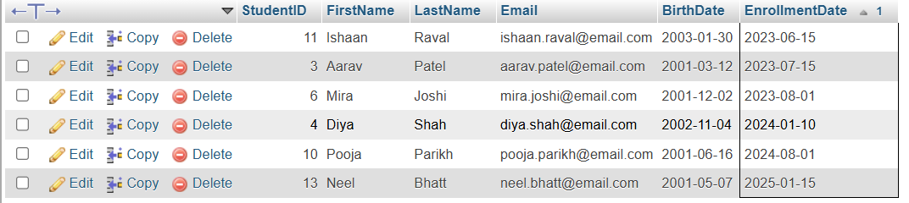

Q.3 Retrieve courses offered by the Mathematics department, with a limit of 5 courses.
Query
SELECT c.CourseID, c.CourseName, c.DepartmentID, c.Credits
FROM Courses AS c
INNER JOIN Departments AS d
ON c.DepartmentID = d.DepartmentID
WHERE d.DepartmentName = 'Mathematics'
ORDER BY c.CourseID
LIMIT 5;
Screenshot
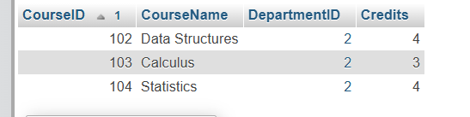

Q.4 Get the number of students enrolled in each course, filtering for courses with more than 5 students.
Query
SELECT c.CourseID, c.CourseName,
COUNT(DISTINCT e.StudentID) AS StudentCount
FROM Courses AS c
INNER JOIN Enrollments AS e
ON c.CourseID = e.CourseID
GROUP BY c.CourseID, c.CourseName
HAVING COUNT(DISTINCT e.StudentID) > 5
ORDER BY StudentCount DESC;
Screenshot
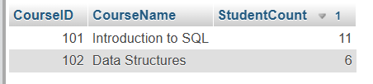

Q.5 Find students who are enrolled in both Introduction to SQL and Data Structures.
Query
SELECT s.StudentID, s.FirstName, s.LastName
FROM Students AS s
INNER JOIN Enrollments AS e
ON s.StudentID = e.StudentID
INNER JOIN Courses AS c
ON e.CourseID = c.CourseID
WHERE c.CourseName IN ('Introduction to SQL', 'Data Structures')
GROUP BY s.StudentID, s.FirstName, s.LastName
HAVING COUNT(DISTINCT c.CourseName) = 2
ORDER BY s.StudentID;
Screenshot
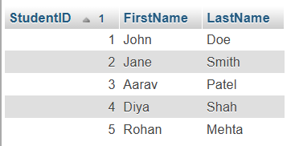

Q.6 Find students who are either enrolled in Introduction to SQL or Data Structures.
Query
SELECT DISTINCT s.StudentID, s.FirstName, s.LastName
FROM Students AS s
INNER JOIN Enrollments AS e
ON s.StudentID = e.StudentID
INNER JOIN Courses AS c
ON e.CourseID = c.CourseID
WHERE c.CourseName IN ('Introduction to SQL', 'Data Structures')
ORDER BY s.StudentID;
Screenshot
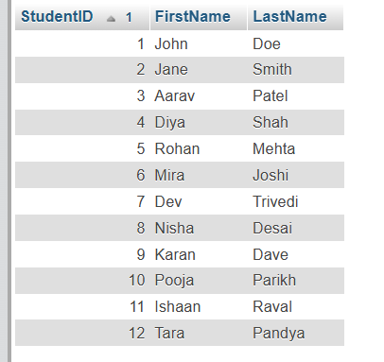

Q.7 Calculate the average number of credits for all courses.
Query
SELECT AVG(Credits) AS AverageCredits
FROM Courses;
Screenshot
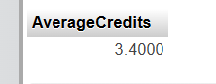

Q.8 Find the maximum salary of instructors in the Computer Science department.
Query
SELECT MAX(i.Salary) AS MaximumSalary
FROM Instructors AS i
INNER JOIN Departments AS d
ON i.DepartmentID = d.DepartmentID
WHERE d.DepartmentName = 'Computer Science';
Screenshot
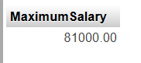

Q.9 Count the number of students enrolled in each department.
Query
SELECT d.DepartmentID, d.DepartmentName,
COUNT(DISTINCT e.StudentID) AS StudentCount
FROM Departments AS d
LEFT JOIN Courses AS c
ON d.DepartmentID = c.DepartmentID
LEFT JOIN Enrollments AS e
ON c.CourseID = e.CourseID
GROUP BY d.DepartmentID, d.DepartmentName
ORDER BY d.DepartmentID;
Screenshot
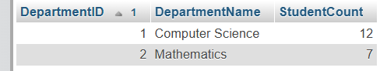

Q.10 INNER JOIN: Retrieve students and their corresponding courses.
Query
SELECT s.StudentID,
CONCAT(s.FirstName, ' ', s.LastName) AS StudentName,
c.CourseID, c.CourseName, e.EnrollmentDate
FROM Students AS s
INNER JOIN Enrollments AS e
ON s.StudentID = e.StudentID
INNER JOIN Courses AS c
ON e.CourseID = c.CourseID
ORDER BY s.StudentID, c.CourseID;
Screenshot
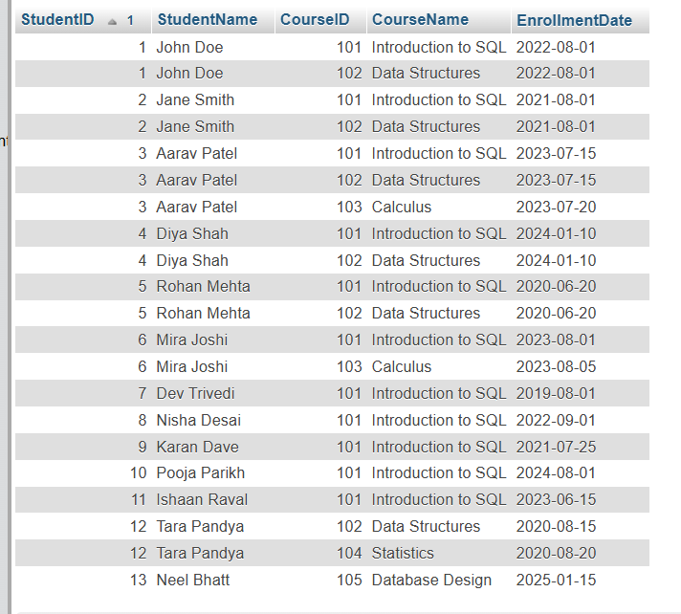

Q.11 LEFT JOIN: Retrieve all students and their corresponding courses, if any.
Query
SELECT s.StudentID,
CONCAT(s.FirstName, ' ', s.LastName) AS StudentName,
c.CourseID, c.CourseName, e.EnrollmentDate
FROM Students AS s
LEFT JOIN Enrollments AS e
ON s.StudentID = e.StudentID
LEFT JOIN Courses AS c
ON e.CourseID = c.CourseID
ORDER BY s.StudentID, c.CourseID;
Screenshot
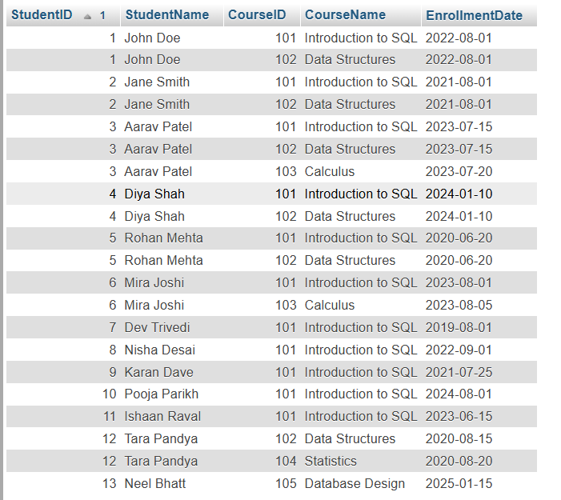

Q.12 Subquery: Find students enrolled in courses that have more than 10 students.
Query
SELECT DISTINCT s.StudentID, s.FirstName, s.LastName
FROM Students AS s
INNER JOIN Enrollments AS e
ON s.StudentID = e.StudentID
WHERE e.CourseID IN (
SELECT e2.CourseID
FROM Enrollments AS e2
GROUP BY e2.CourseID
HAVING COUNT(DISTINCT e2.StudentID) > 10
)
ORDER BY s.StudentID;
Screenshot
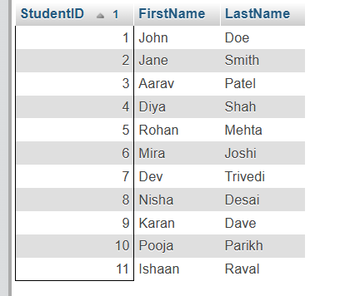

Q.13 Extract the year from the EnrollmentDate of students.
Query
SELECT StudentID, FirstName, LastName, EnrollmentDate,
YEAR(EnrollmentDate) AS EnrollmentYear
FROM Students
ORDER BY StudentID;
Screenshot
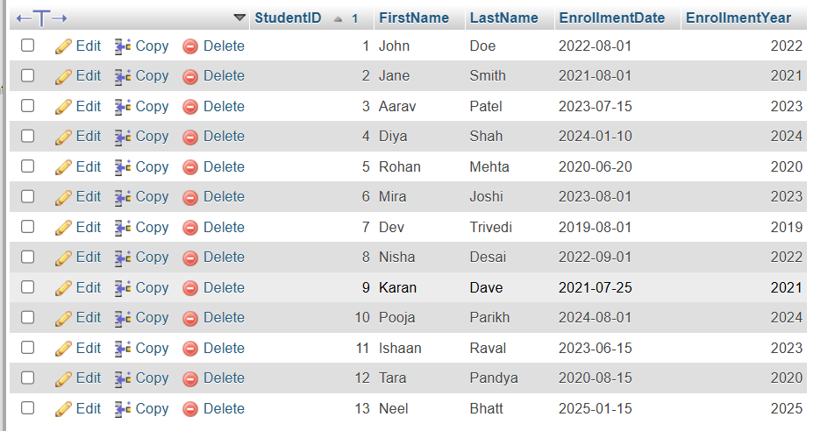

Q.14 Concatenate the instructor's first and last name.
Query
SELECT InstructorID,
CONCAT(FirstName, ' ', LastName) AS InstructorFullName,
Email, DepartmentID
FROM Instructors
ORDER BY InstructorID;
Screenshot
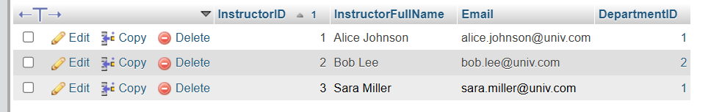

Q.15 Calculate the running total of students enrolled in courses.
Query
SELECT EnrollmentID, StudentID, CourseID, EnrollmentDate,
COUNT(*) OVER (
ORDER BY EnrollmentDate, EnrollmentID
ROWS BETWEEN UNBOUNDED PRECEDING AND CURRENT ROW
) AS RunningEnrollmentTotal
FROM Enrollments
ORDER BY EnrollmentDate, EnrollmentID;
Screenshot
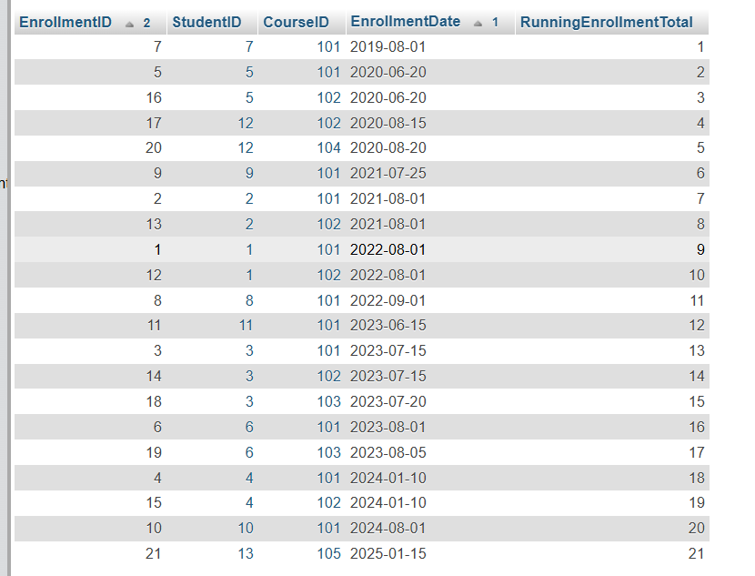

Q.16 Label students as 'Senior' or 'Junior' based on enrollment date. If enrollment is more than 4 years before the current date, label 'Senior'; otherwise label 'Junior'.
Query
SELECT StudentID, FirstName, LastName, EnrollmentDate,
CASE
WHEN EnrollmentDate < DATE_SUB(CURDATE(), INTERVAL 4 YEAR)
THEN 'Senior'
ELSE 'Junior'
END AS StudentLevel
FROM Students
ORDER BY StudentID;
Screenshot
